Final Exam

Yixin Yin

1.

No, it can’t. In my opinion, if arrays grow upward, it is not secure.

“Within the topic of stack buffer overflows, an often discussed but rarely seen architecture is one in which the stack grows in the opposite direction. This change in architecture is frequently suggested as a solution to the stack buffer overflow problem because any overflow of a stack buffer that occurs within the same stack frame can’t overwrite the return pointer. Further investigation of this claimed protection finds it to be a naive solution at best. Any overflow that occurs in a buffer from a previous stack frame will still overwrite a return pointer and allow for malicious exploitation of the bug. At most this means that growing the stack in the opposite direction will change some details of how stack buffer overflows are exploitable, but it will not reduce significantly the number of exploitable bugs”. –wikipedia/stack_buffer_overflow

Although you can not use stack overflows to replace the return address by overflowing the arrays, if buffer overflow happens, the data was written to unknown address. That is terrible and you may not detect it. So it may bring more problems.

2.

When we type in the url, the following things happened: (That is the best version I found on Internet. I cite it in the reference for this question)

1. browser checks cache; if requested object is in cache and is fresh, skip to #9
2. browser asks OS for server's IP address
3. OS makes a DNS lookup and replies the IP address to the browser
4. browser opens a TCP connection to server (this step is much more complex with HTTPS)
5. browser sends the HTTP request through TCP connection
6. browser receives HTTP response and may close the TCP connection, or reuse it for another request
7. browser checks if the response is a redirect or a conditional response (3xx result status codes), authorization request (401), error (4xx and 5xx), etc.; these are handled differently from normal responses (2xx)
8. if cacheable, response is stored in cache
9. browser decodes response (e.g. if it's gzipped)
10. browser determines what to do with response (e.g. is it a HTML page, is it an image, is it a sound clip?)
11. browser renders response, or offers a download dialog for unrecognized types

(1) Tools and technologies I used:

whois, nslookup, traceroute, bgp looking glasses

(2) How does your machine communicate with other hosts on the local network? What protocols does it use and how do they work?

In the local network, if we want to communicate with other hosts, we first need to know their MAC address in the local network. We use ARP protocol to get the destination MAC address. So in this way, the hosts in the same LAN can communicate by using TCP/IP protocol.

(3) How does your machine communicate outside of the local network?

First the host should have an IP address to outside world. If the machine wants to communicate outside of the local network, it must go out from its router. Then the router redirect the packet to where it should go. The router keeps a routing table so that it knows where to transport the packets. BGP protocols may be used to get the full information of the network and build the routing table. Other protocol like OSPF may also helpful to build the entire network topology.

(4) How does your local network (LAN) access the Internet?

First the host got our IP address from ISP. Then our host needs to know where to go. By using the DNS protocol, the host get the IP address for the specific domain name. That is the destination IP address. Our local network then access the Internet first via our router and then connect to the remote host as we discussed in (3) . There are several ways to connect to the Internet. For example, we could use cable or Wi-Fi or ADSL to connect to the Internet.

(5) What IP is hosting the domain? How do you find this out? Who owns  the domain and IP?

First I use nslookup to find the IP address of the domain.

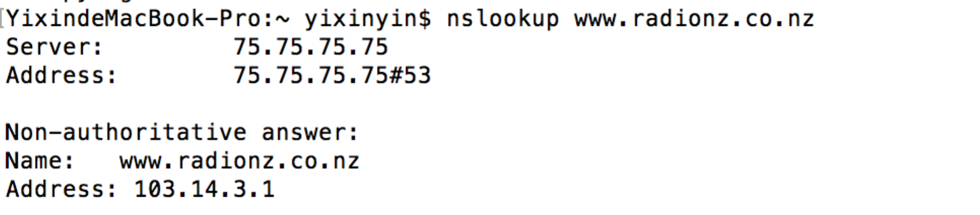

the ip is 103.14.3.1

then I use whois –h to get the information

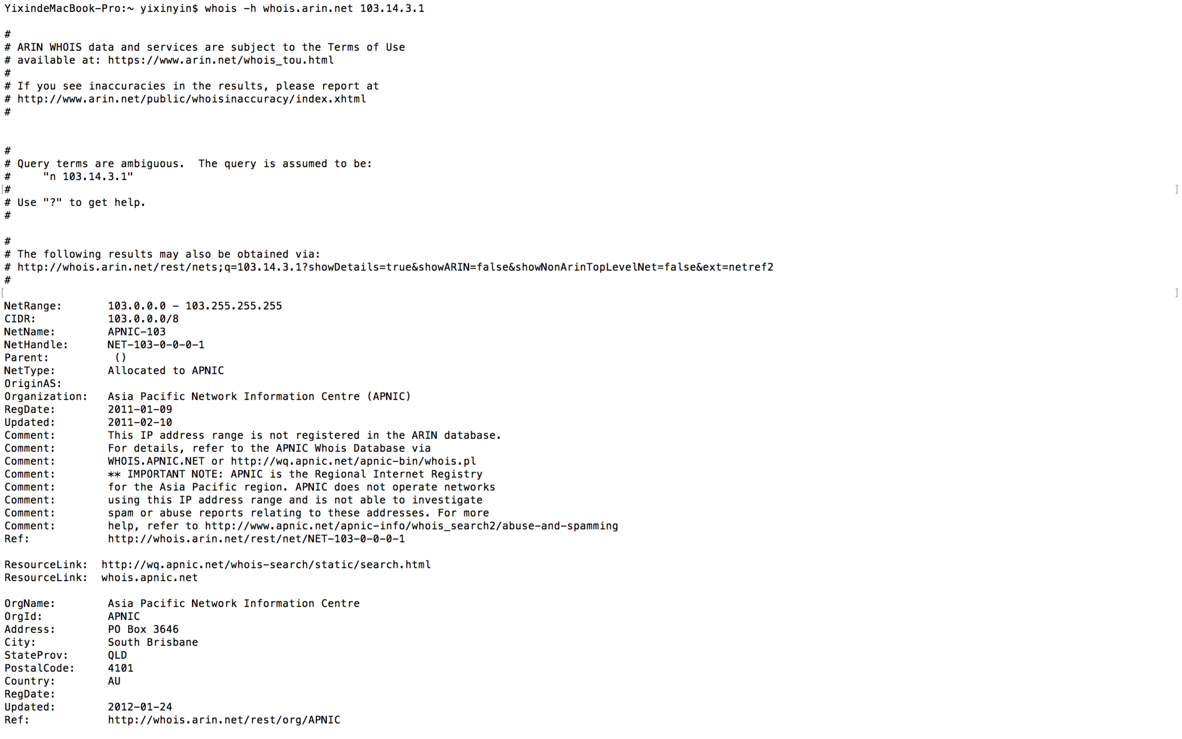

the organization is 

so APNIC owns the IP address.

(6) What Autonomous Systems does your traffic pass through?

First I use traceroute command to get the result

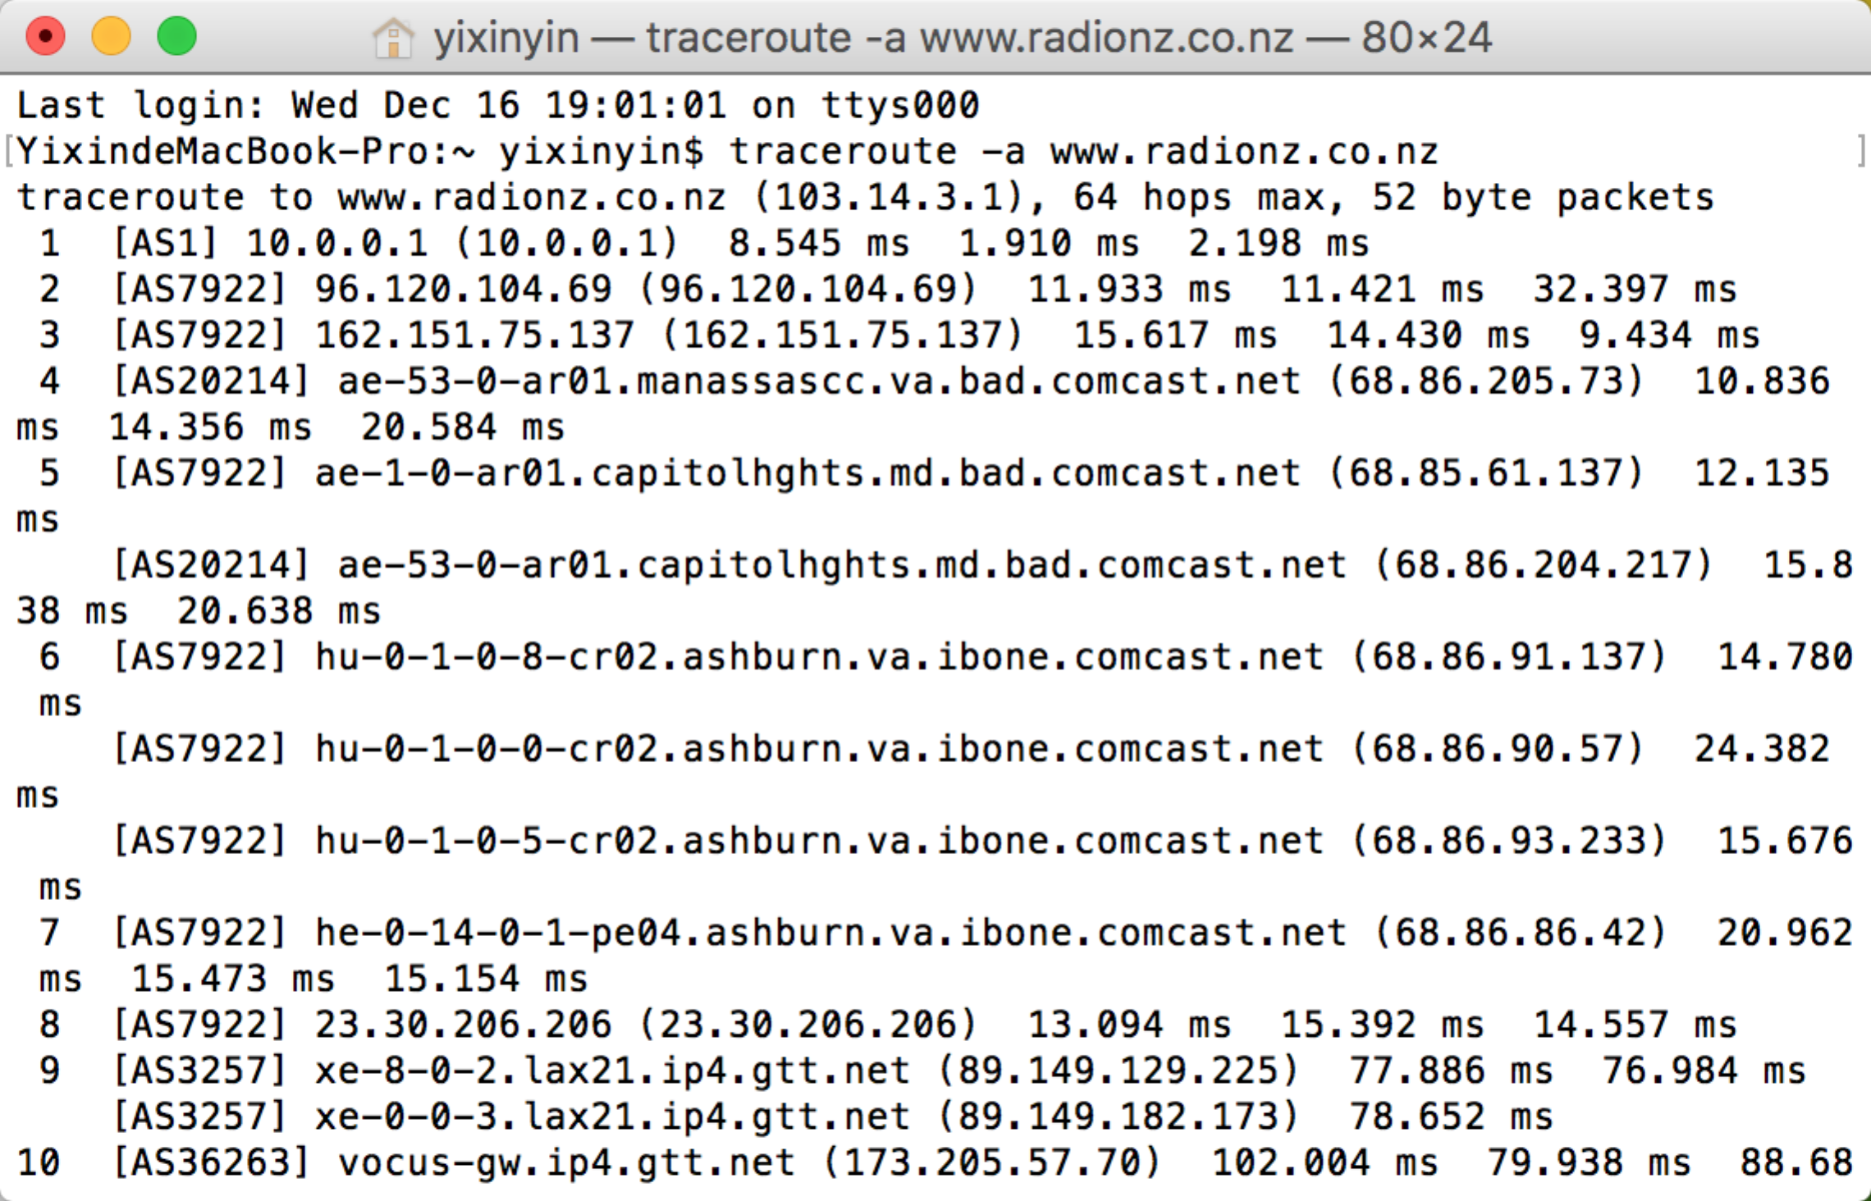

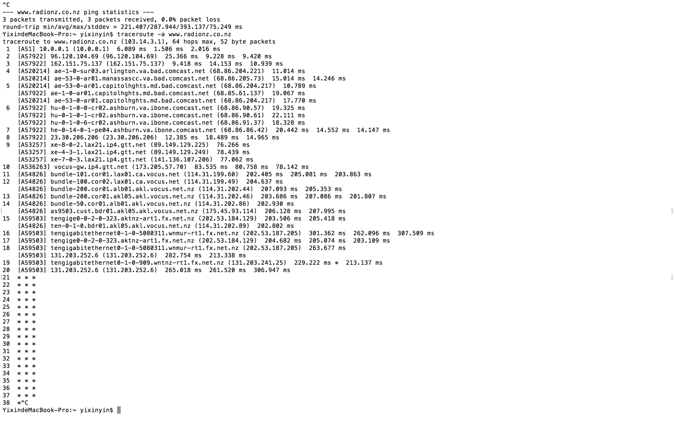

I also use looking glass server to check the ASes

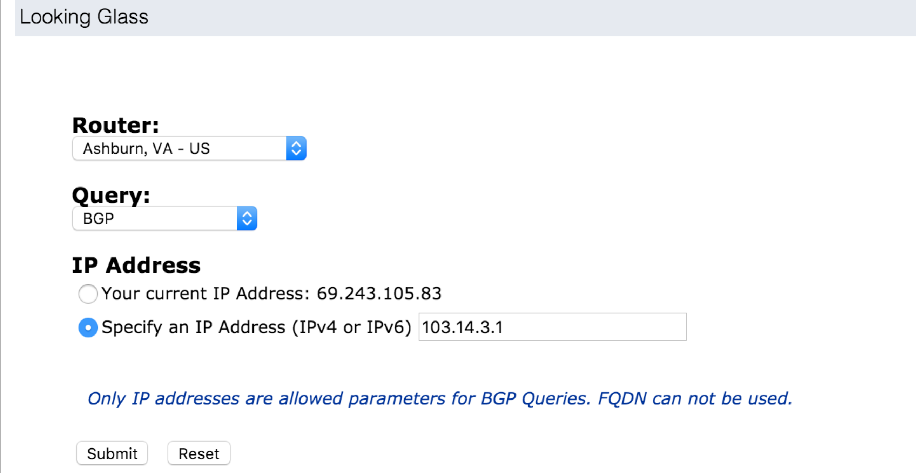

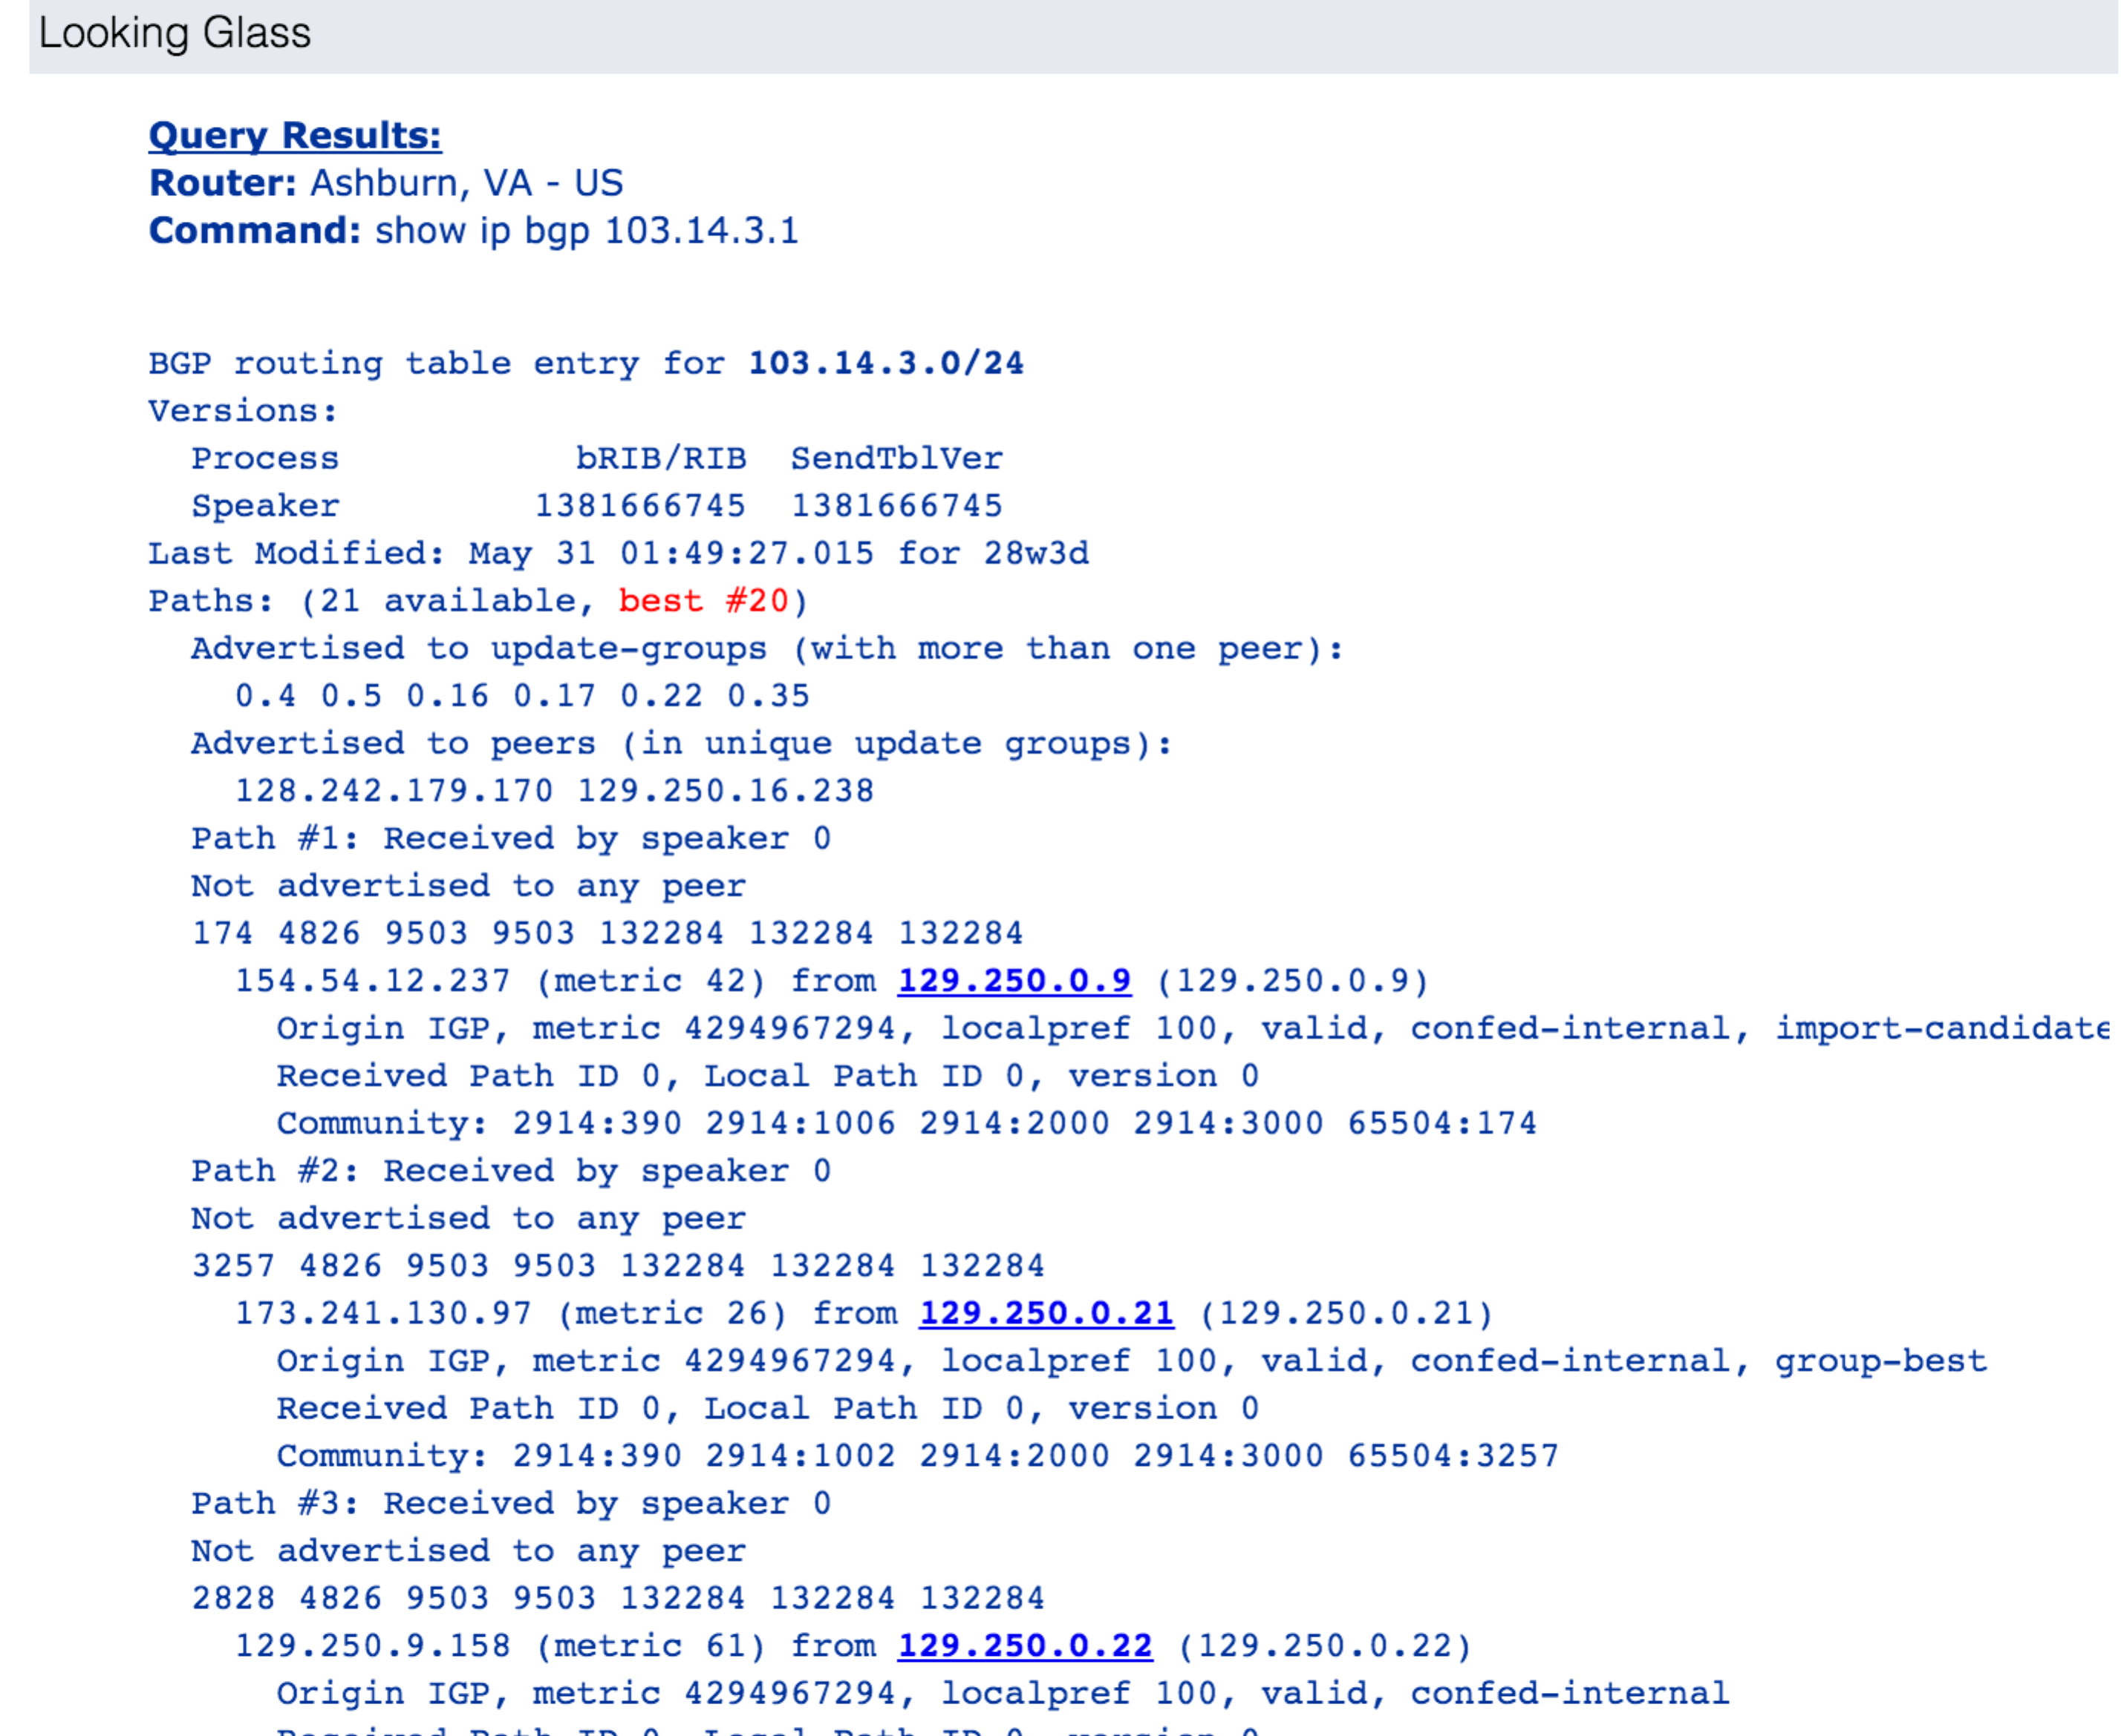

I finally use Hurricane looking glass to get a better result.

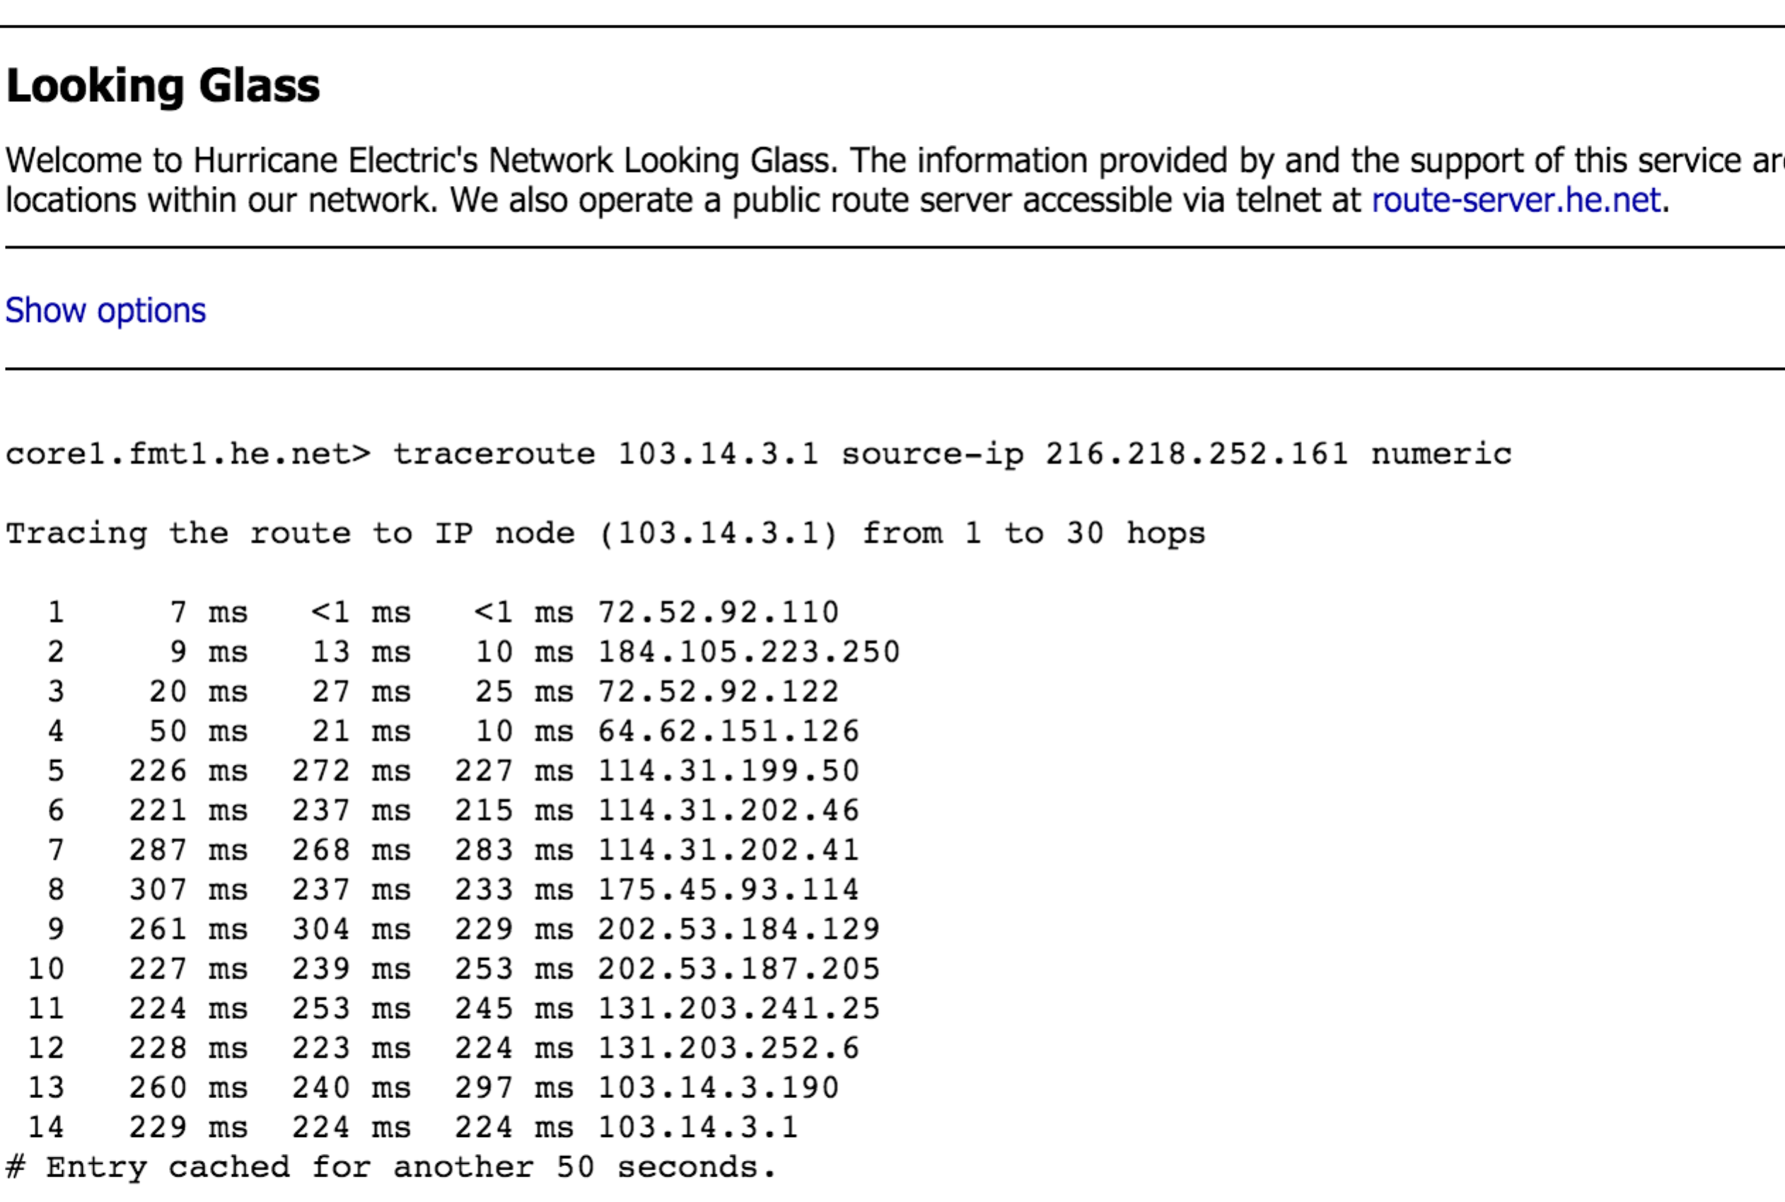

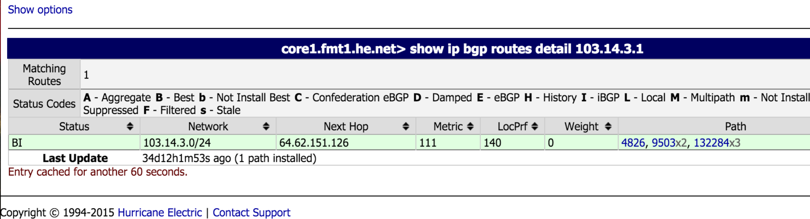

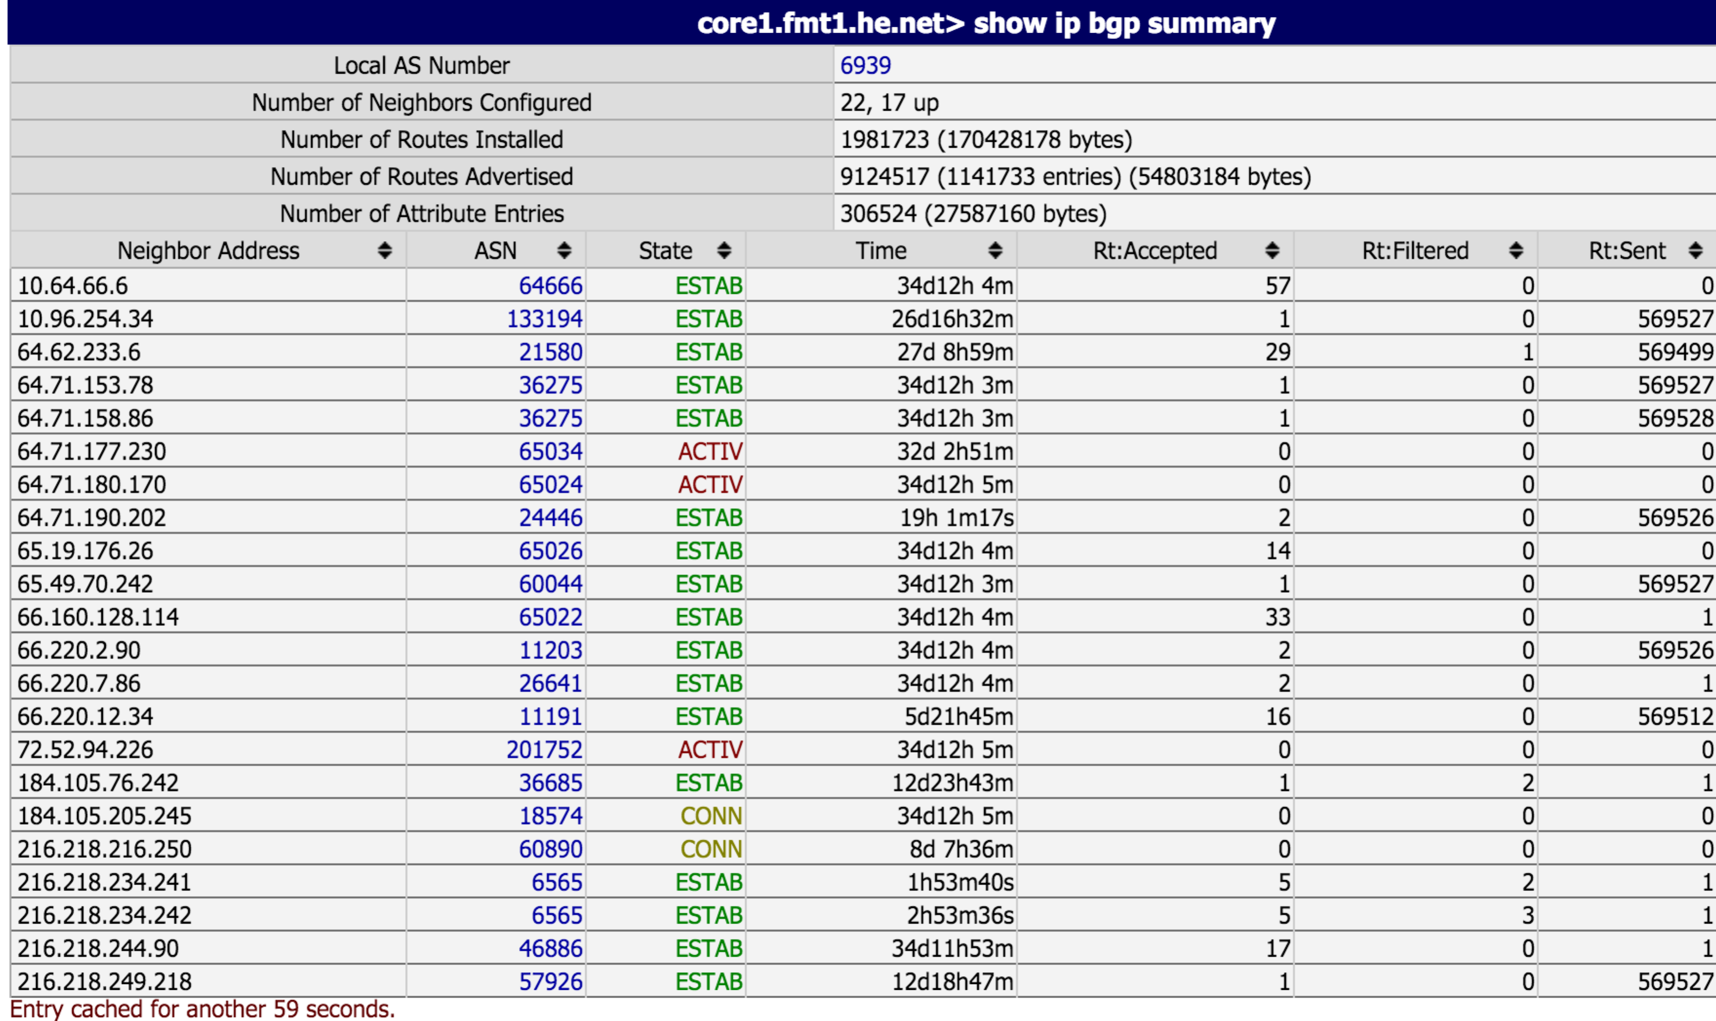

3.

We have done this in our assignments. The following sites give a detailed tutorial <http://www.computersecuritystudent.com/SECURITY_TOOLS/PASSWORD_CRACKING/lesson2/>

Tools need:

KALI Linux, john the ripper, common Linux commands(mount, samdump)

Suppose we want to obtain the password from a windows system. The hash is NTLM hash.

1. Install KALI Linux on the system in order to get the hashes
2. Use fdisk –l to check the disk and mount /dev/sda1 to mount the disk
3. Then use the following command to go to the WINDOWS/system32/config directory

cd /mnt

ls

cd WINDOWS/system32/config

1. get the hashes and write the hashes into a txt file

samdump2 SAM system > ~/hashes.txt

(5)Use john command to decode the hashes john ~/hashes.txt

(6) At the same time use the online hash cracking service(search through pre-build dictionary) and try to get the plaintext.

In fact, I think we could just use the hashes rather than crack them. Sometimes we even do not need to know the plain text of the password.

For the defense of the password attack, I think first for windows system, we should not store LM hashes because it is not safe and easy to crack. Second we should design a password that is complex enough so that it will be hard to crack in a limited time. Full (whole) disk encryption which can also prevent an intruder from ever accessing the OS and passwords stored on the system. It will convert all the data to unreadable code.

4.

As we know, most spear phishing email will give you a link to click. The link will redirect you to their fake website and ask you to input your information maybe like username, password. In this way they got your information and do bad things.

1. Since we don’t have any specialized tools, what we can do here is defending passively and observation…

Normally, it is easy to identify the spear phishing email by checking the sender’s email and the link’s url. If an email asks you to click an url, the sender must be act as a staff or maybe some company. What you need to do is to check the authorized website and never input anything in the given url. If you think a website is a phishing website, you should not input anything or simply input something wrong to test. Furthermore, install an effective anti-virus software. It will alert you if you are in dangers.

1. The best implementation we can simply do is on the endpoints. We could install anti-virus software in our hosts. We could install a filter on our router to block some specific attacker IP address.
2. We could use Wireshark to check all the incoming traffic and check the specific IP address. We then keep a blacklist that keeps all the attacker.
3. We could install Security Onion on our local network and use it to monitor the traffic. Use Snort or Bro to alert when the network was attacked.

5. It overwrites the EIP register. The CPU decides which instruction to execute next by reading the value of the EIP register and executing the instruction that is located at that memory address.

The EIP register always contains the address of the next instruction to be executed. So If we control EIP, we could control where the program will go and then inject our shellcode into the specific address properly. In that way our shellcode was executed.

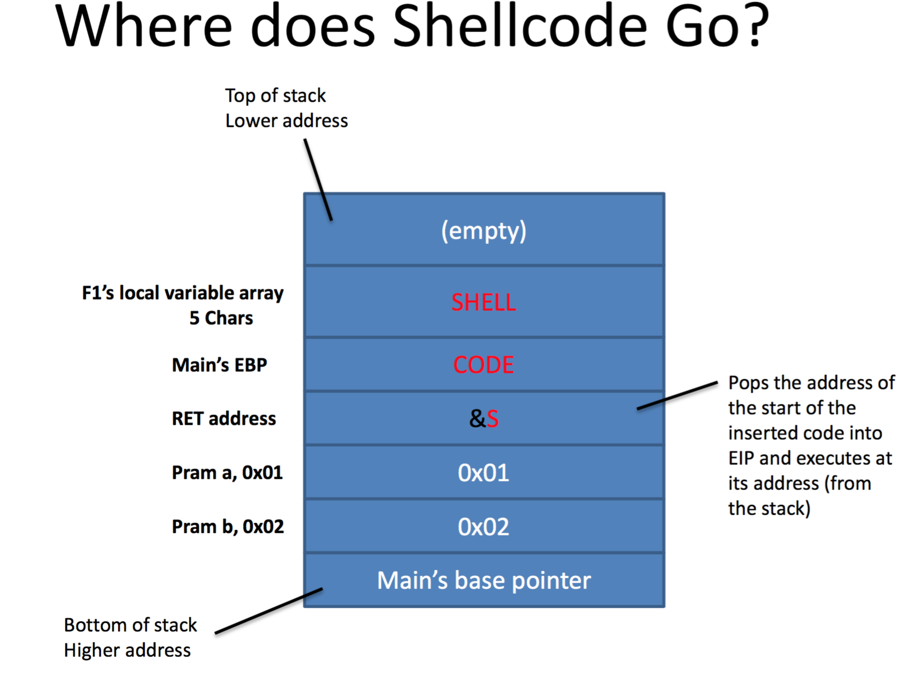

6.

I use the whois command to get the record.

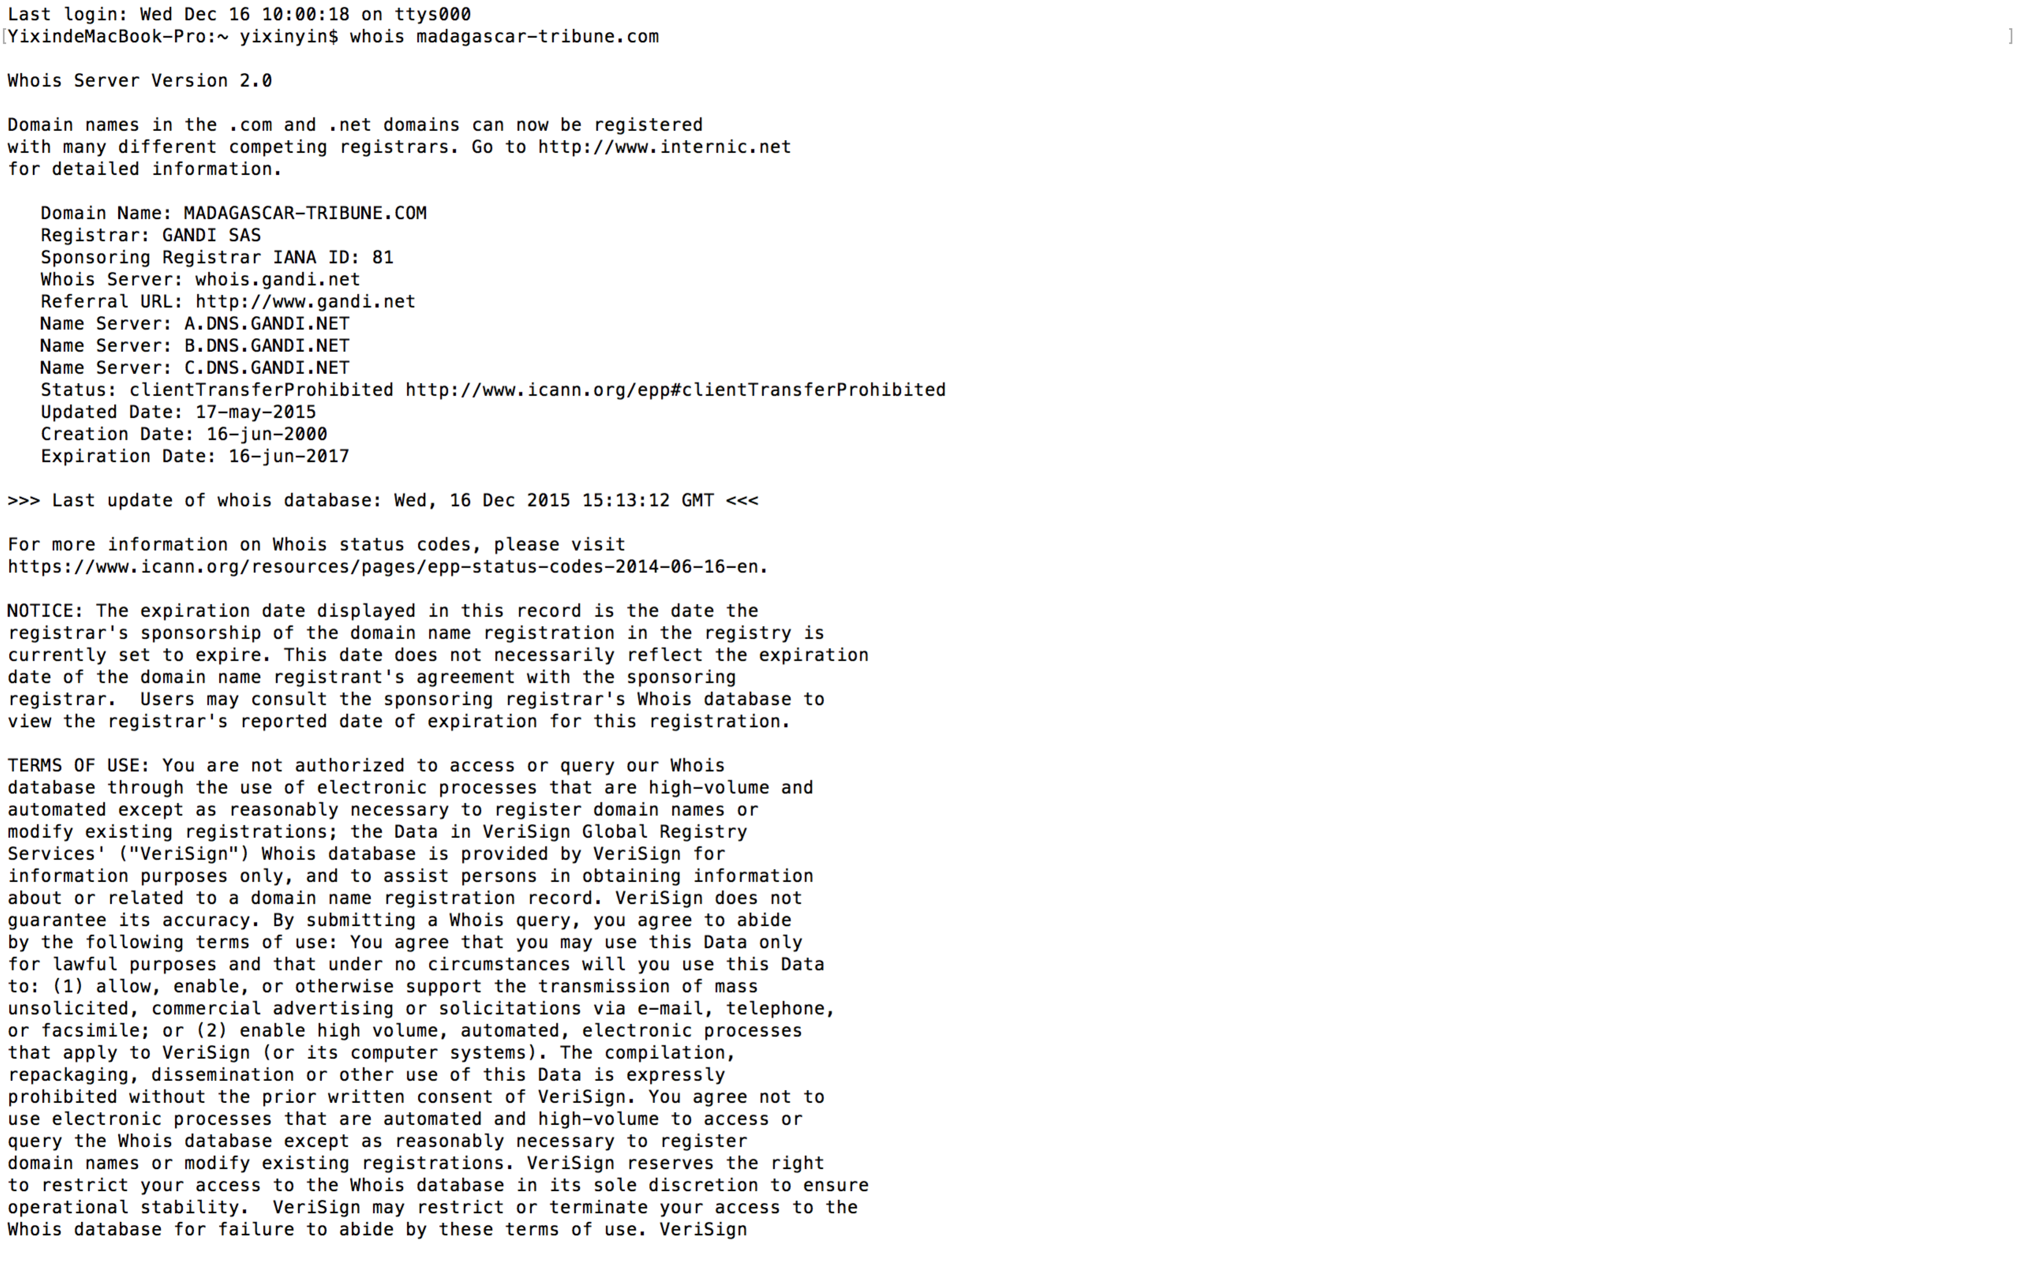

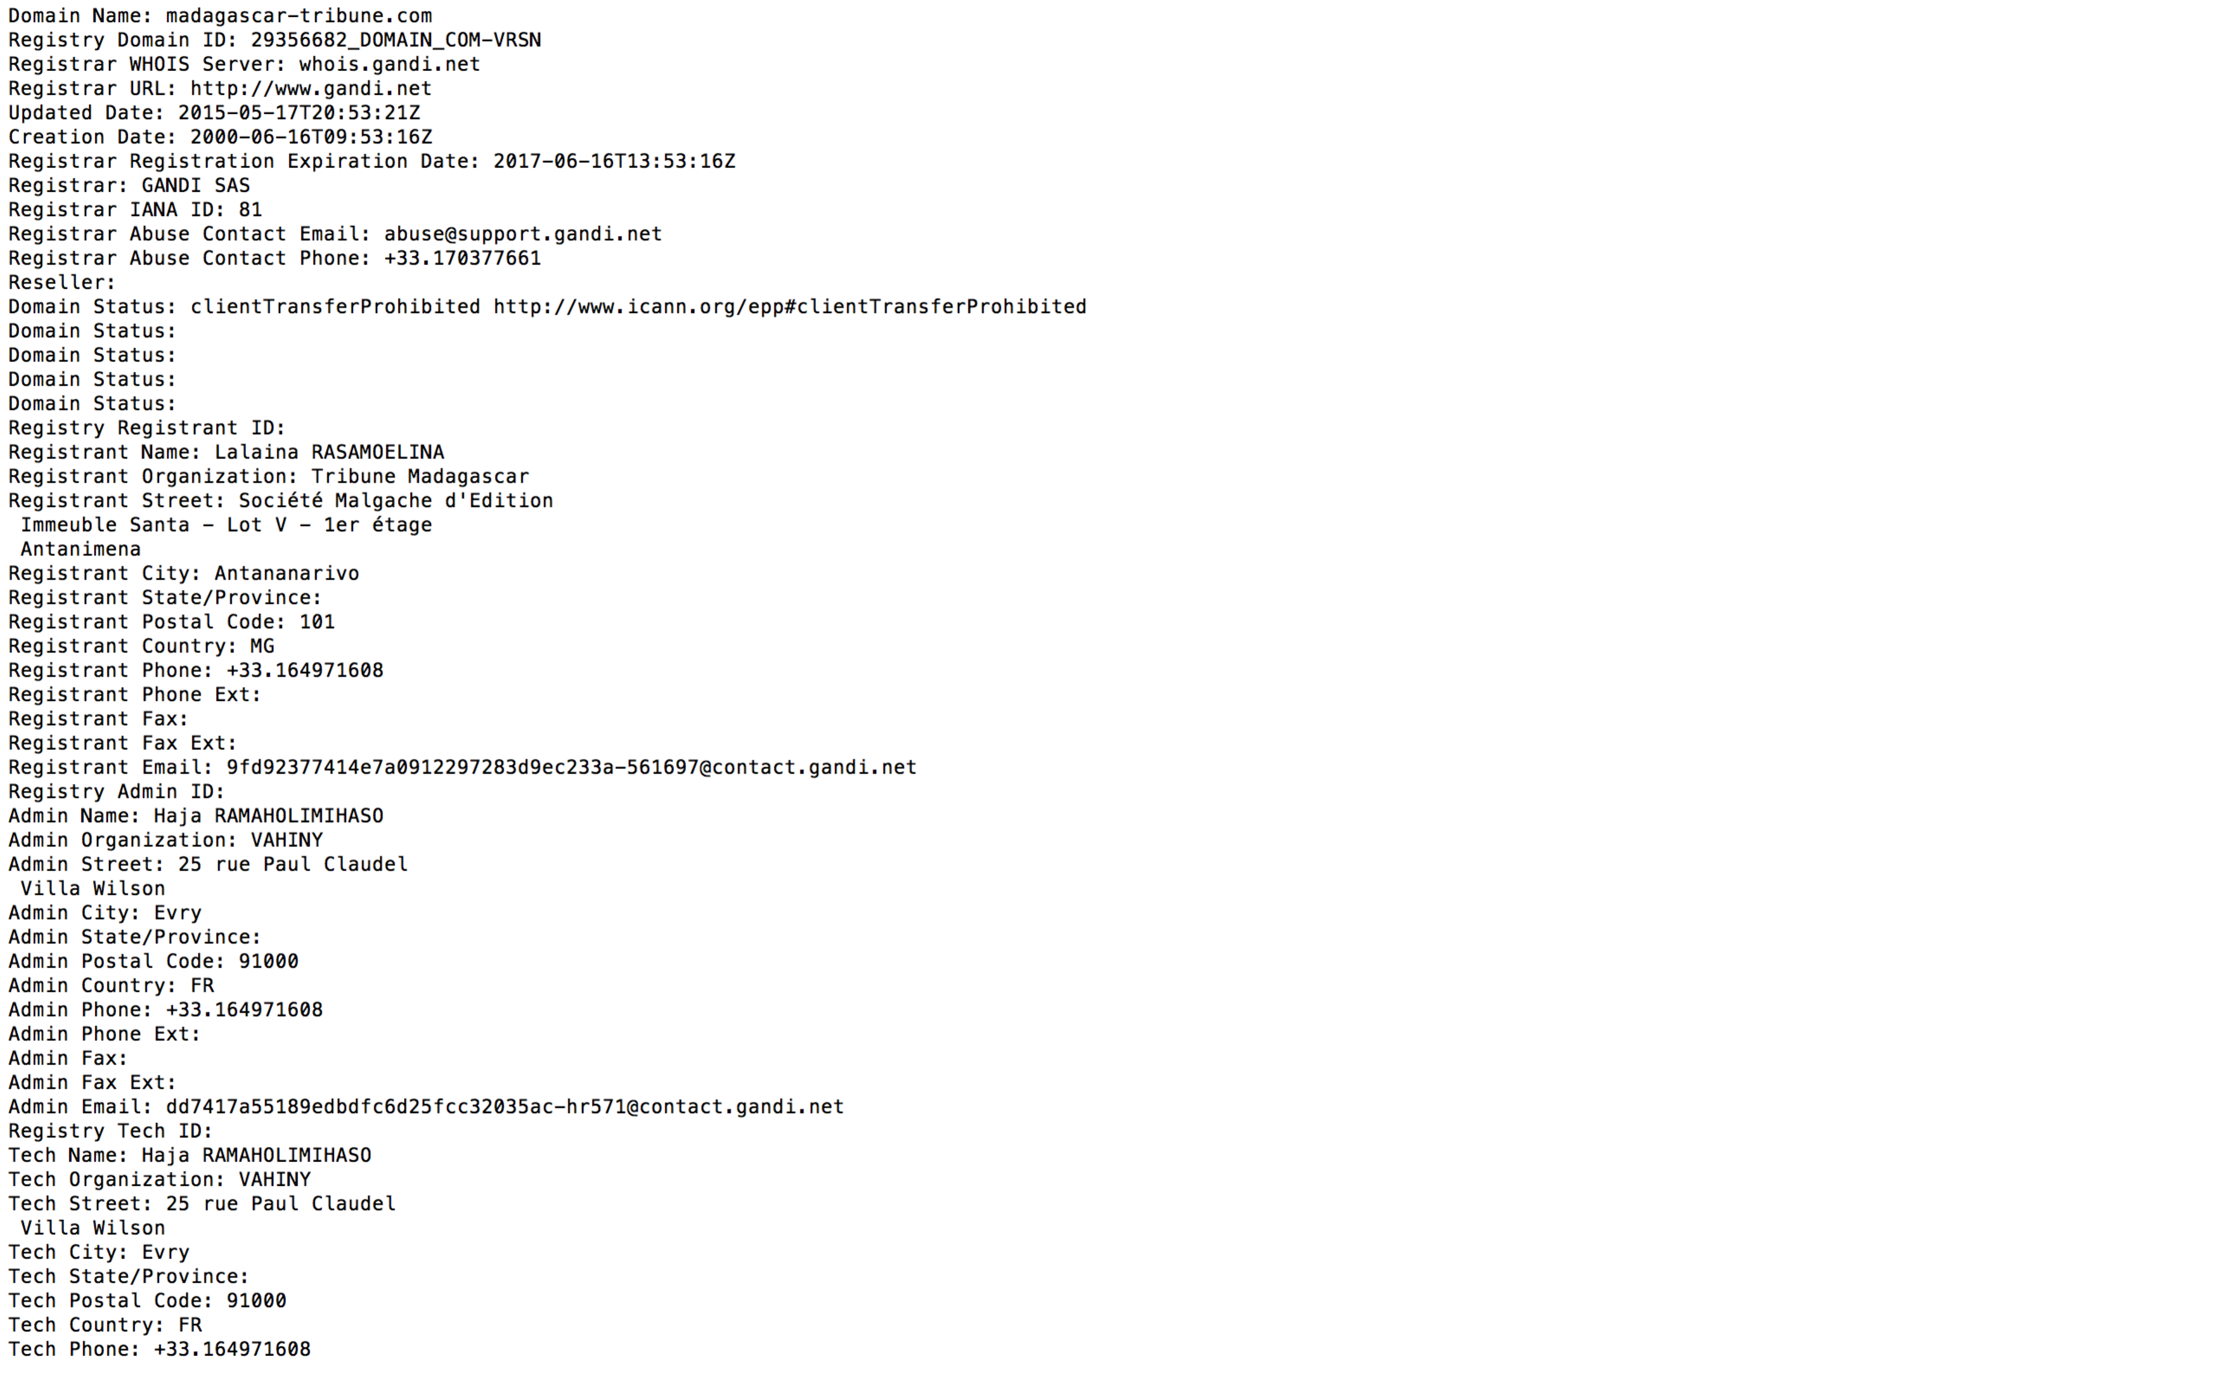

so we know that:

1. Registered Location:

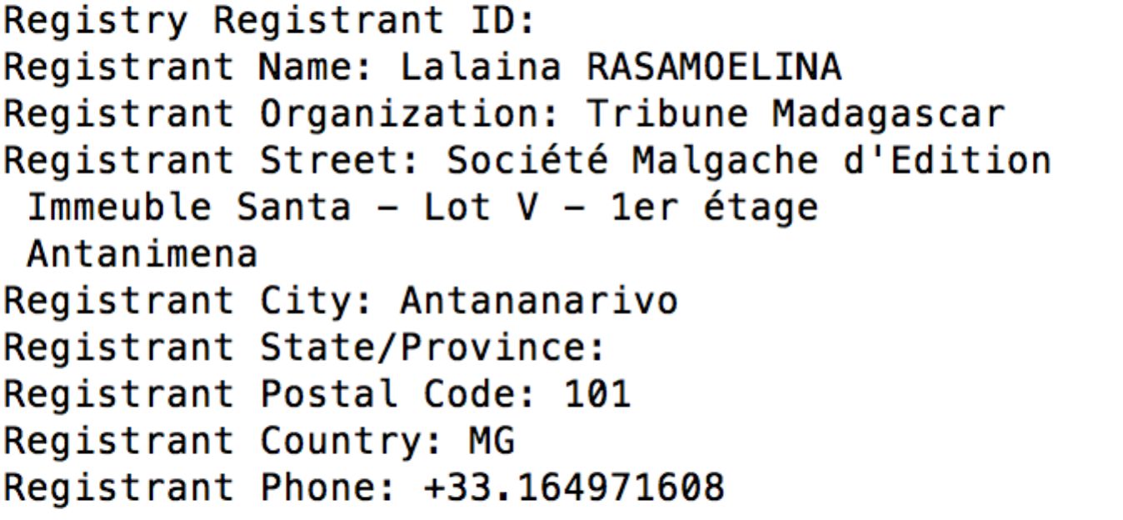

Country: MG

Providence: not given

City: Antananarivo

1. Hosted location:

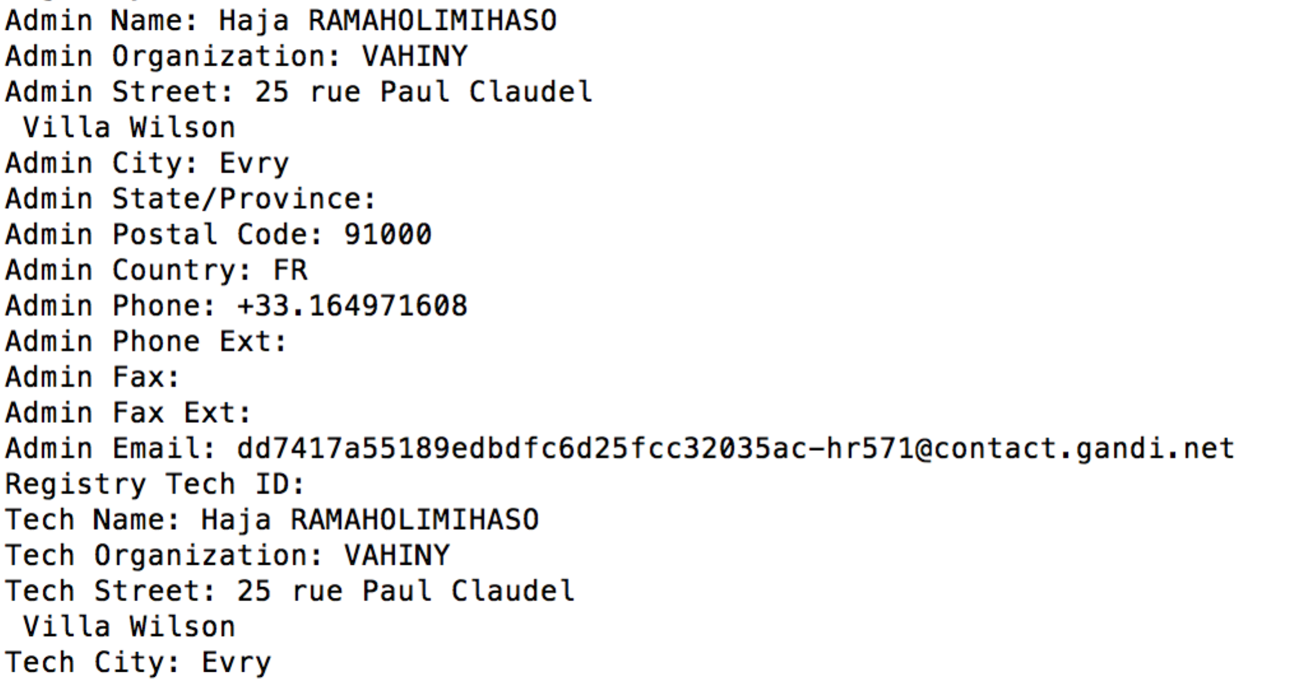

so it is hosted in France

1. The registered location is in MG while the admin location is in France. They are located in different places but their contact phone is the same. Both are +33.164971608. It is interesting.

Just input

whois madagascar-tribune.com

in the command line and we could get the information.

7.

10.78.224.0/27

00001010. 01001110. 11100000.00000000

the red component is the subnet

the netmask is 255.255.255.224

So the last 5 bit are for the hosts

2^5 = 32

so at most 32 hosts are there.

8.

The result for the first command is :

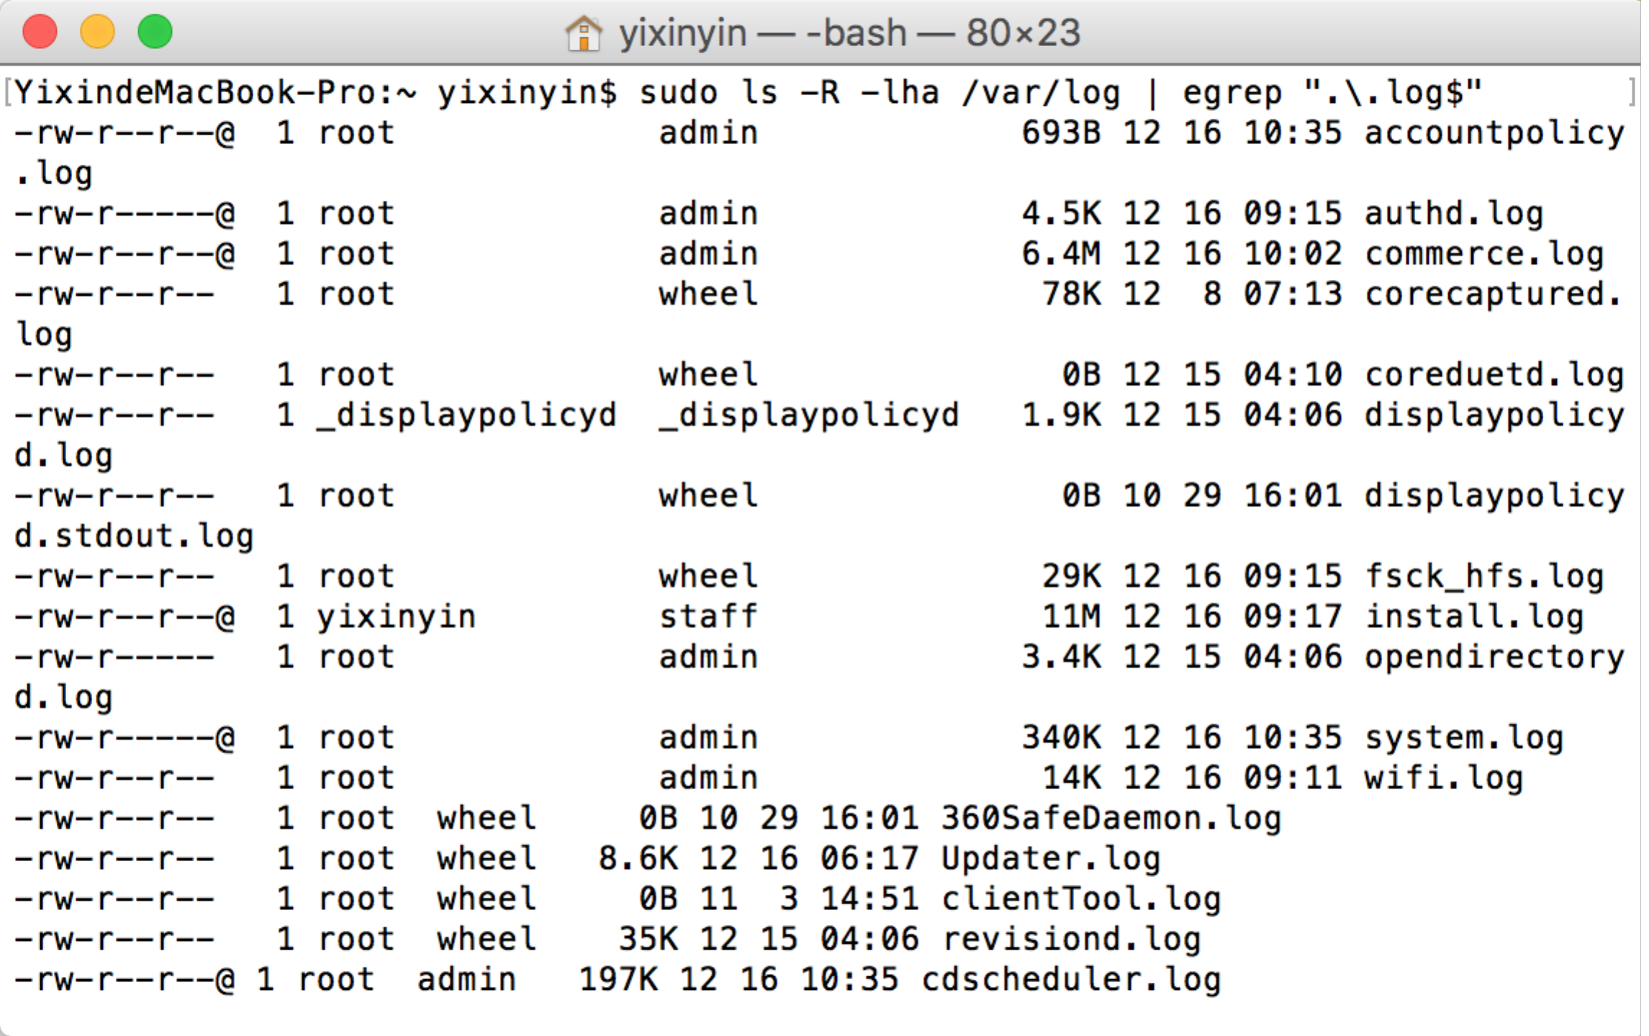

This command is used to list(long format include a lot specific information such as permissions modify date and so on, print size in human readable format)all the files(include hidden file and the files in the sub directory) that is ended with .log under the directory /var/log

the result for the second command is:  
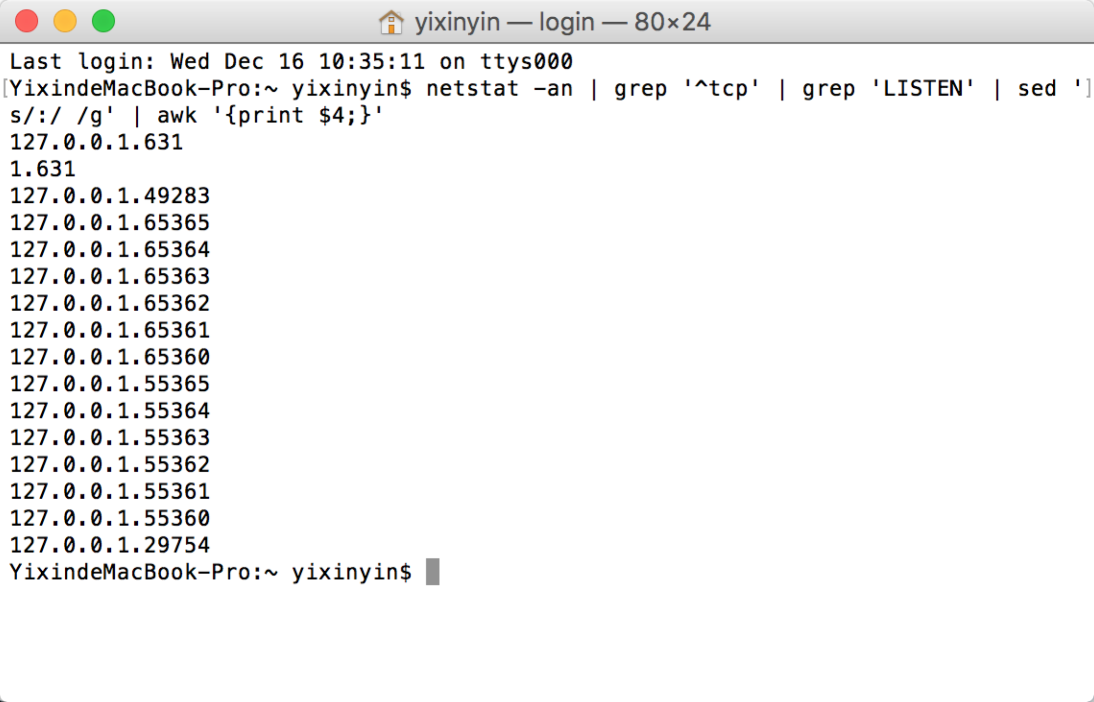

this command is a little more complex.

First netstat –an, it displays all active connections and the TCP and UDP ports. Displays active TCP connections, however, addresses and port numbers are expressed numerically and no attempt is made to determine names.

Then grep ‘^tcp’ get all the lines that started with “tcp”

Then grep ‘LISTEN’ get all the line contains ‘LISTEN’

Then sed ‘s/:/ /g’ substitute all the : with space

Until now we get the following:

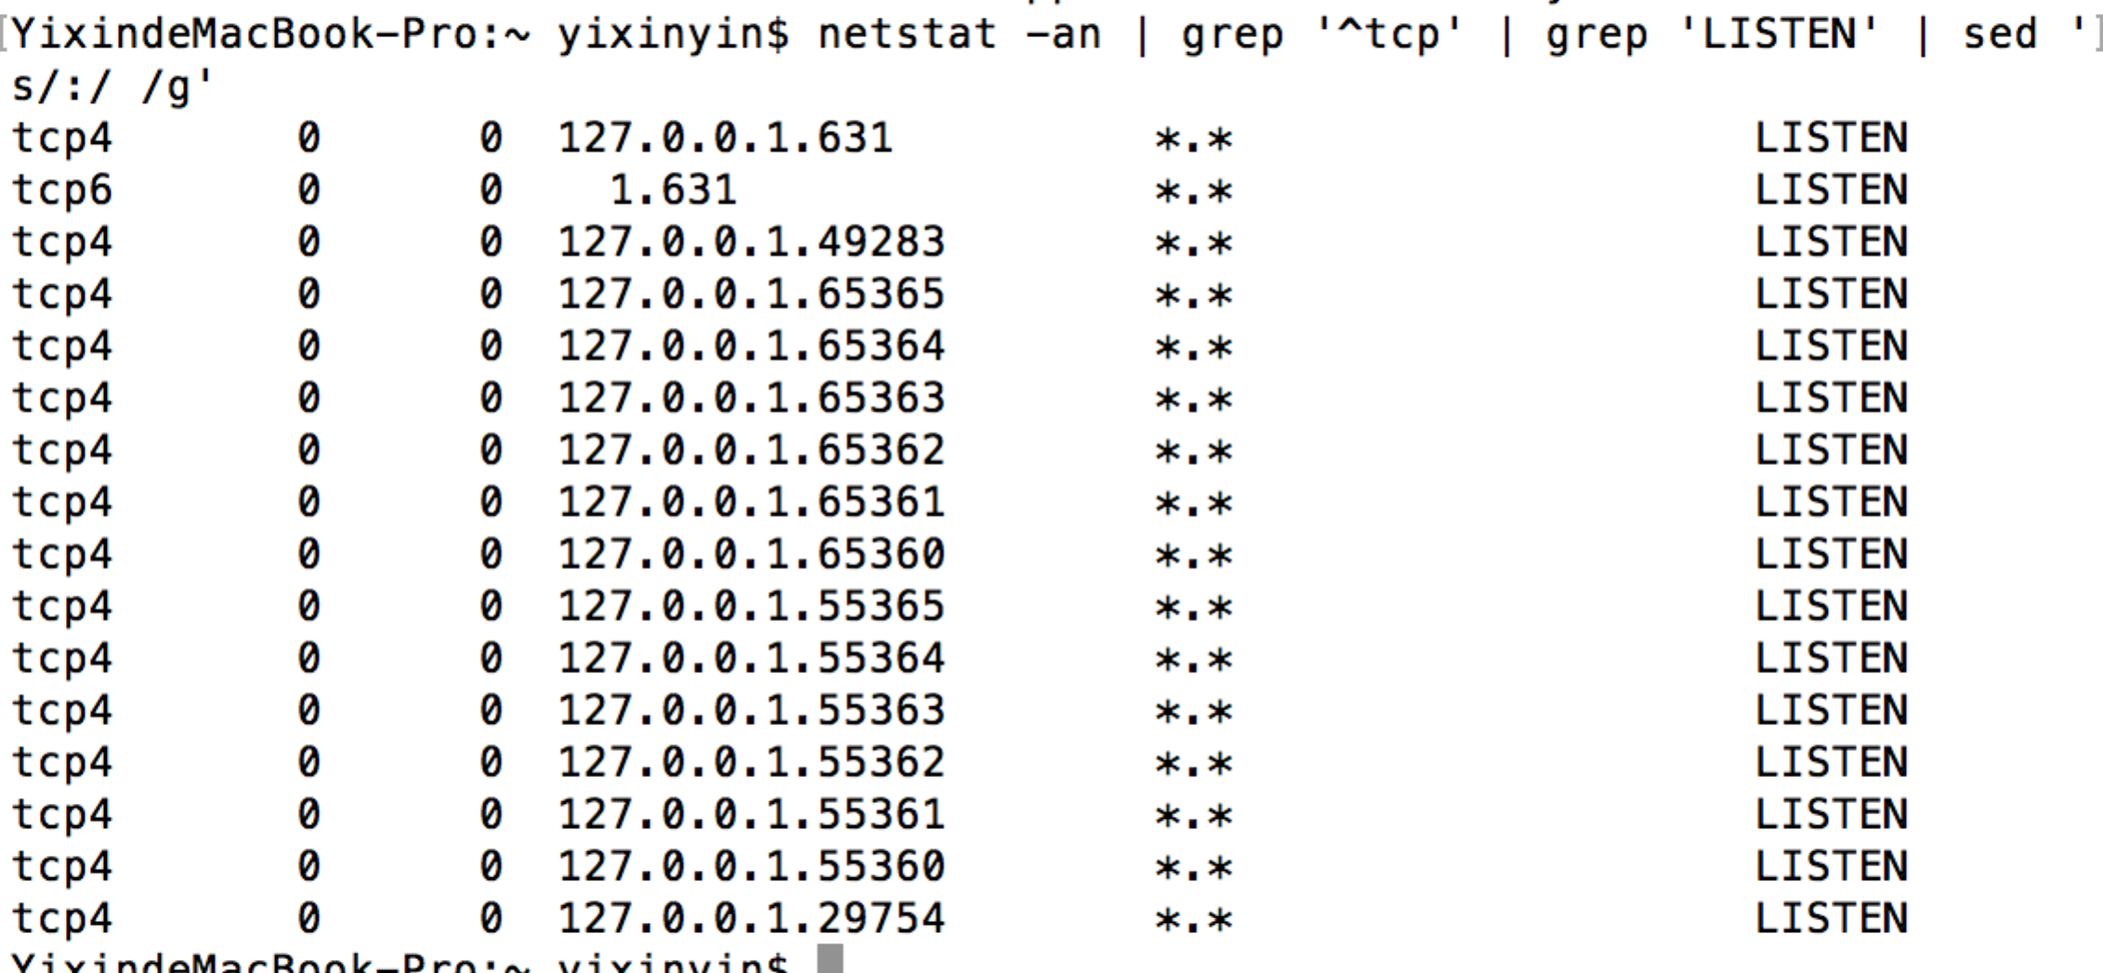

Then we simply print the fourth column and get the final result

I think the first command is just a way to list all the .log file under /var/log directory.

If you want to put the netstat log to the directory, you first need to change the privilege of the /var/log file. Then simly add “> /var/log/mylog.log” to the second command. As a result, the log will be stored in the /var/log directory and if you use the first command, you could find the mylog.log file.

9.

In order to improve the security of the network, I will do the following things.

First I will perform auditing and mapping. I need to get a clear understanding of the entire network’s infrastructure. For instance, I need to know the vendor, location and basic configuration of firewalls, routers, switches, Ethernet cabling and ports, and wireless access points. During this process, I could find specific security vulnerabilities or ways in which I could increase security, performance and reliability. Second, I will try to keep the network up to date. Then I will review the setting for any insecure configuration and look into any other security features or functionality that I am not currently using. Then I will consider MAC address filtering. It will give me more control over the devices on the network. Furthermore, I will implement VLANS to segregate traffic. By using VLAN, I could group Ethernet ports, wireless access points and users among multiple virtual networks. Then I will use VPNs to encrypt select PCs or servers. Finally I may try to encrypt the entire network using IPsec.

For the visibility into network traffic, I will build intrusion detection system(IDS) and intrusion prevention system(IPS). They are devices or software application that monitors network or system activities for malicious activities or policy violations and produces report to a management station. After looking for information about this, I think it is quite useful but a little bit complex to implement. I think in our attack and defense exercise, Security Onion is more like an IDS. Security Onion has wireshark, snort, bro and other web application to monitor the traffic and give a feedback. If we get familiar with it, it will help us a lot so that we could identify known and unknown attack by using it.

For active defense, we could use Honeypots and Tar Pits. The tools ate intended to hold an attack in place for a time. Honeypot provides data and possible samples to potentially help protect against attackers and Tar Pit will slow an attacker by intentionally delaying initial response to incoming connections. These two tools may be useful for active defense.

There are some other policies that I think is important. So I will list some here. They are central command and control, distributed enforcement and integrated actionable intelligence. The following diagram gives one of the architecture of the a safe network.

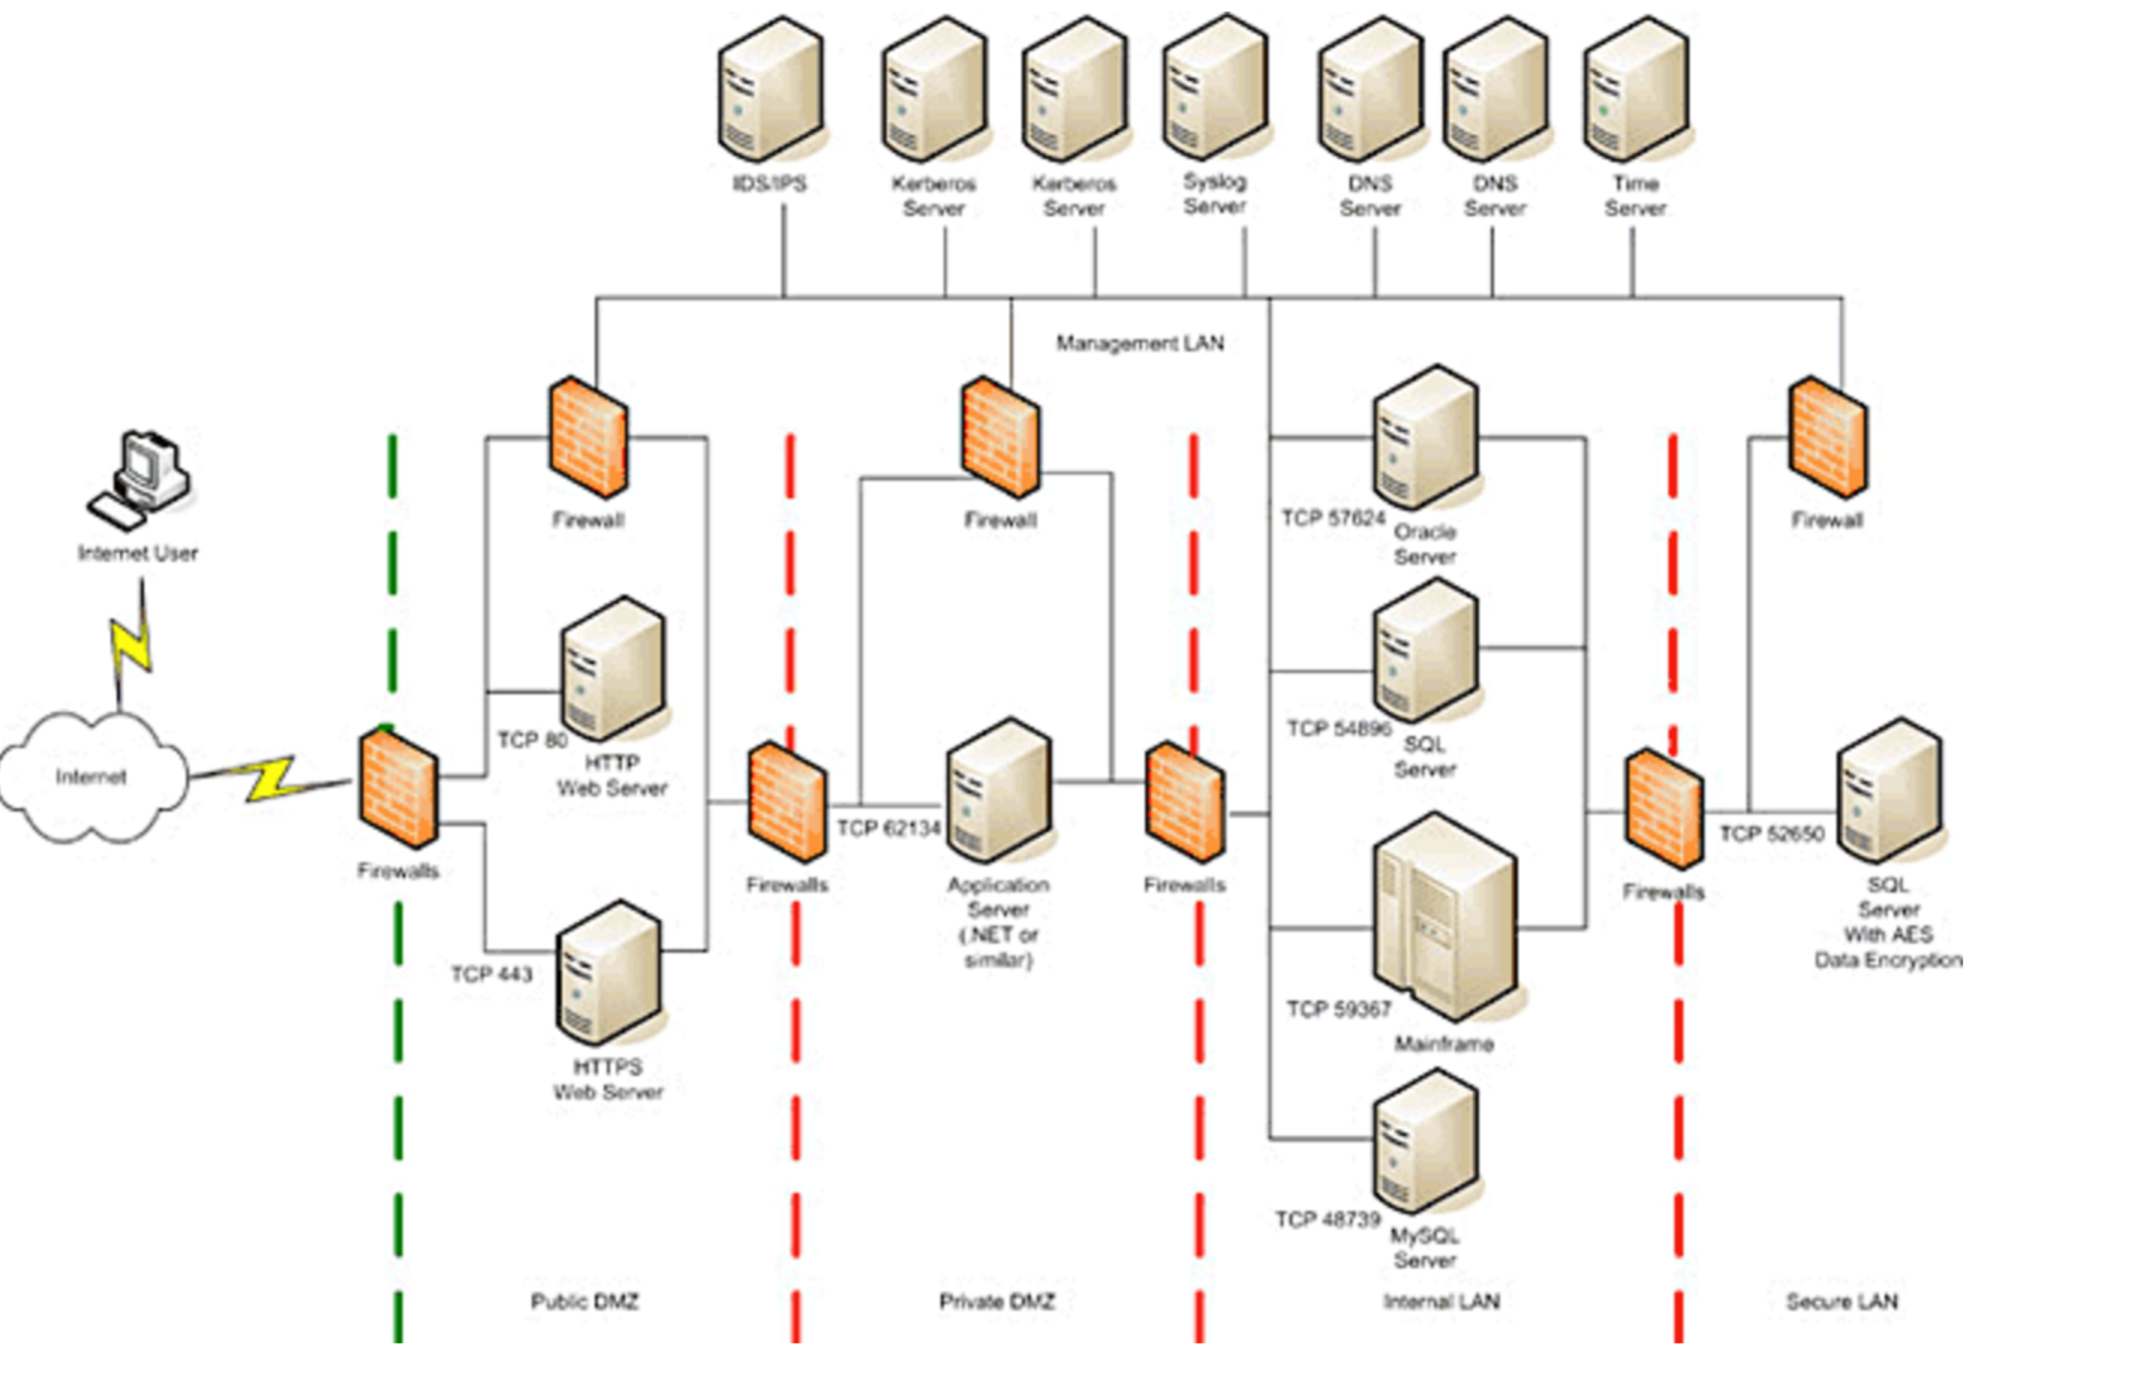

10.

For the security of the endpoints, we can do a lot to improve it. First we need to do is to establish strong passwords. This is the easiest thing we can do to strengthen our security. Second we need to put up a strong firewall. A firewall protects your network by controlling internet traffic coming into flowing out of your business. Third, we need to install antivirus protection. Fourth, we should update the program regularly. Frequently updating your programs keeps you up-to-date on any recent issues or hole that programmers have fixed. Fifth, we need to backup regularly. Scheduling regular backups to an external hard drive or in the cloud, is a painless way to ensure that all your data is stored safely. Sixth, we need to monitor diligently. We need to deploy someone to monitor the traffic and give a feedback every week to ensure the safety. Seventh, we need to be careful with e-mail, IM and surfing the Web. It is common for a unsuspecting employee to click on a link or download an attachment that they believe is harmless. So we also need to educate the employees. We need to teach them the basic network knowledge and teach them how to identify the malicious software. That is also important because most attack is based on your mistake.

11.

I think it is because the NULL ‘0x00’ character will terminate the code because the null byte means the end of string and shall stop it. If there is a ‘0x00’ in your shellcode, the code will terminate and the rest of your shellcode will not execute. That is not right. So we should remove the NULL character. The following is the explanation on Wikipedia. It is reasonable.

Most shellcodes are written without the use of [null](https://en.wikipedia.org/wiki/Null_character) bytes because they are intended to be injected into a target process through [null-terminated strings](https://en.wikipedia.org/wiki/Null-terminated_string). When a null-terminated string is copied, it will be copied up to and including the first null but subsequent bytes of the shellcode will not be processed. When shellcode that contains nulls is injected in this way, only part of the shellcode would be injected, making it incapable of running successfully.

12.

The LANMAN password algorithm is insecure is weak because:  
(1)passwords are limited to a maximum of only 14 characters, given a maximum keyspace 95^14 with 95 ASCII printable characters.

(2) Secondly, passwords longer than 7 characters are divided into two pieces and each piece is hashed separately; this weakness allows each half of the password to be attacked separately at [exponentially lower](https://en.wikipedia.org/wiki/Exponential_growth) cost than the whole, as only  different 7-character password pieces are possible with the same character set.

(3) The LM hash also does not use [cryptographic salt](https://en.wikipedia.org/wiki/Salt_(cryptography)), a standard technique to prevent [pre-computed dictionary attacks](https://en.wikipedia.org/wiki/Pre-computed_dictionary_attack).

(4) A final weakness of LM hashes lies in their implementation — since they change only when a user changes their password, they can be used to carry out a [pass the hash](https://en.wikipedia.org/wiki/Pass_the_hash) attack.

13.

In my point of view, I think process & application monitoring and installing antivirus are the two best way to make the network safe although these two options seem to be the easiest to implement. I think they are effective to protect our network without cost too much resource.

As we know, our system need to be patched. That is what all of us will do, and it does not need any technique. What we need to do is click the update and install. So I don’t consider it as a way to protect the network. For the firewall configuration, I think it is not practical. You can not monitor all the traffic and configure them on your own just by using the firewall. I think the firewall can just block the simple attack and give us a relative safe environment at most. For stopping unnecessary services, I think we should do that but it is not so important. It can reduce the risk but not so effective. For removing unnecessary accounts and resetting passwords, I think the attacker can attack you and get all your information even they don’t know your passwords. For installing antivirus, I think it is reasonable and important. Since the antivirus software are the professional people design together and it could do better than what we do ourselves. However, each coin has two sides, the antivirus may be just the worst virus ever. Since we need to rely on the software, it is really risky. But for now I think it is the most effective way if the antivirus is friendly. For process & application monitoring, I think it is important because it is what we can do and need to do. We could check the process that is suspected by monitoring. A lot of malicious software are just a process and if we find it and terminate it. It is done. But we need to learn some basic knowledge to identify and monitoring a process. That is very important.

Reference:

1. <http://www.computerhope.com/issues/ch001358.htm>

2.<http://stackoverflow.com/questions/2092527/what-happens-when-you-type-in-a-url-in-browser>

3.<https://www.us.ntt.net/support/looking-glass/>

4.<http://www.computersecuritystudent.com/SECURITY_TOOLS/PASSWORD_CRACKING/lesson2/>

5.<http://www.dummies.com/how-to/content/prevent-hacking-with-passwordcracking-countermeasu.html>

6.<https://en.wikipedia.org/wiki/Shellcode>

7.<https://en.wikipedia.org/wiki/LM_hash>

8.<http://www.networkworld.com/article/2175048/wireless/8-ways-to-improve-wired-network-security.html>

9.<https://www.sans.org/reading-room/whitepapers/detection/understanding-ips-ids-ips-ids-defense-in-depth-1381>

10.<http://www.welivesecurity.com/2013/11/19/active-defense-good-protection-doesnt-need-to-be-offensive/>

11.<http://rsmus.com/what-we-do/services/risk-advisory/the-ultra-secure-network-architecture.html>

12.<http://www.entrepreneur.com/article/217484>

13. <https://en.wikipedia.org/wiki/Stack_buffer_overflow>